**COMSATS UNIVERSITY ISLAMABAD,**

**LAHORE CAMPUS**



**ASSIGNMENT NO. 1**

**NAME:** Malaika Sohail

**REGISTRATION NO.:** SP23-BCS-066

**COURSE TITLE:** Object Oriented Programming

**COURSE CODE:** CSC-241

**SUBMITTED TO:** Sir Shahid Bhatti

**SECTION:** B

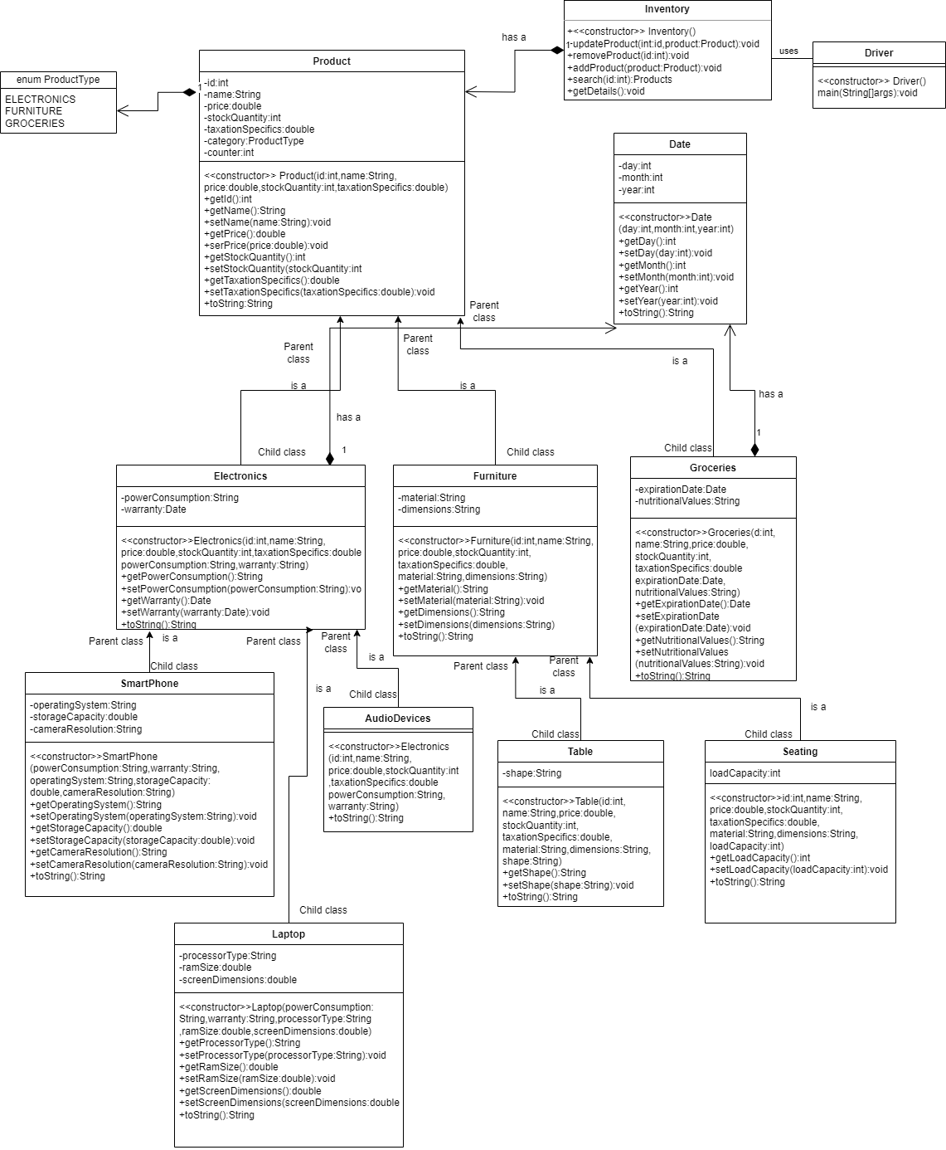

**DOCUMENTATION**

**Enumeration:**

1. ELECTRONICS
2. FURNITURE
3. GROCERIES
4. **Class Product:** Class Product serves as template.
5. **Attributes:**
6. int id: a unique identifier for each product
7. String name: name of a product
8. double price: Price of a product
9. int stockQuantity: Quantity of product in stock
10. double taxationSpecifics: Tax on the product
11. ProductType category: Tells to which category the product belongs
12. static int counter: used for generating unique ids
13. **Methods:**
14. Parameterized constructor
15. Getters and setters for all attributes (except for counter)
16. toString():String
17. **Class Inventory:** This class contains all the necessary functions/methods

**Methods:**

1. updateProduct(product:Product):Helps to update the product be it price,quantity etc
2. removeProduct(id:int):Helps to remove a product
3. addProduct(product:Product):Helps to add a product
4. search():helps in searching a particular product
5. getDetails(): Displays all the products along with their details
6. **Enumeration productType**
7. ELECTRONICS
8. FURNITURE
9. GROCERIES
10. **Subclasses of class Product:**
11. **Class Electronics:**

* **Attributes**

Additional attributes:

1. String powerConsumption: Tells us about the power consumed in electronics
2. Date warranty: Warranty of the electronic item

* **Methods**

1. Parameterized constructor
2. Getters and setters for the additional attributes
3. toString():String
4. **Class Furniture:**

* **Attributes**Additional attributes:

1. String material: Tells about the material of furniture
2. String dimensions: Tells about dimensions of furniture

* **Methods**

1. Parameterized constructor
2. Getters and setters for the additional attributes
3. toString():Stirng
4. **Class Groceries:**

* **Attributes**

Additional attributes are:

1. Date expirationDate: Tells about expiry date of grocery product
2. String nutritionalValues: Tells the nutritional values of the product

* **Methods**

1. Parameterized constructor
2. Getters and setters for the additional attributes
3. **Class Date:** Class Date is composed in Groceries for expirationDate and class Groceries has ”has a” relation with class Date

* **Attributes:**

1. int day
2. int month
3. int year

* **Methods:**

1. Parameterized constructor
2. Getter and setter for all attributes
3. toString():String
4. **Sub-classes of class Electronics:**
5. **Class SmartPhone:**

* **Attributes**

Additional attributes are:

1. String operatingSystem
2. String storageCapacity
3. String cameraResolution

* **Methods**

1. Parameterized constructor
2. Getters and setter for the additional attributes
3. toString():String
4. **Class Laptop:**

* **Attributes**

Additional attributes are:

1. String processorType
2. double ramSize
3. double screenDimensions

* **Methods**

1. Parameterized constructor
2. Getters and setter for the additional attributes
3. toString():String
4. **Class Audio**

* **Methods**

1. Parameterized constructor
2. toString():String
3. **Sub-classes of class Furniture**
4. **Class Seating**

* **Attributes**

Additonal attributes are

1. int loadCapacity

* **Methods**
  + 1. Parameterized constructor
    2. Getters and setter for the additional attributes
    3. toString():String

1. **Class Table**

* **Attributes**

Additional attributes are

1. String shape

* **Methods**

1. Parameterized constructor
2. Getters and setter for the additional attributes
3. toString():String
4. **Driver Class**

In this class objects of different classes are made and necessary methods are called.

* **Method**

1. main(String[]args):void